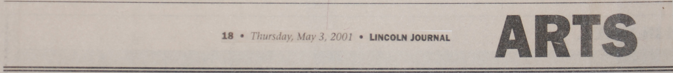

“Artist Hans Breiter showing work at Boston gallery until June”, Lincoln Journal, 05/3/03

A.M. Smolski

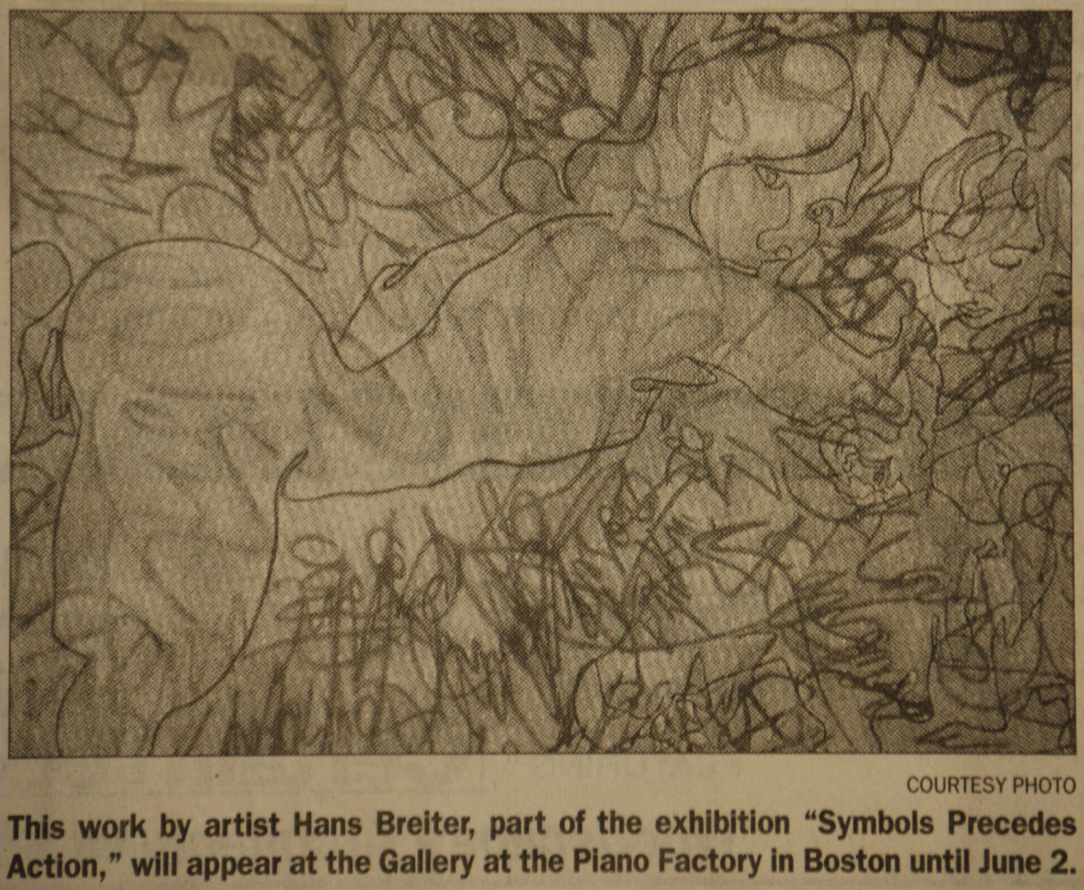

The Gallery at the Piano Factory in Boston will exhibit new works by Hans Breiter from May 3, through June 2. The exhibition entitled “Symbol Precedes Action”, will have an evening opening from 6-9 p.m. on May 3. General visiting hours are Friday 5-8 p.m., Saturday and Sunday 1-4 p.m.

The paintings in this show focus on language, and “treat text as a visual enterprise” (Christopher Millis). Thus, some paintings portray piles of letters that illustrate what happens to words when speech is over. Other works show phrases from conversations swirling around each other in space to demonstrate their primary communication, namely the flow of emotion between individuals. Graphic illustrations of this emotional communication by the flow of words through space include transcriptions of psychotherapy sessions.

The current body of work builds upon paintings that have provoked strong reactions in the past. Regarding a show of work depicting conversations flowing through space, David Borsook, Director of the Massachusetts General Hospital Pain Center, noted “These pieces go beyond anything you see at the Brooklyn Museum…in fact, his last paintings upset me for weeks…I wish I could pay [him] to stop…”.

These works contain strong influences from Breiter’s past as a graffiti artist in Chicago, and subsequently, as a studio-bound painter of classical nudes.

Consistent with his cultural heritage as a mischling, Breiter’s most recent work weaves very disparate elements of words and figures together. The words stem from emotionally intense conversations with the individuals portrayed on the canvas, of from statements by artists and critics that are relevant to the events illustrated. The words twist about the canvas like World War I biplanes in a dogfight, and are configured to act as the furniture in the scene, or the latticework holding the human figures. The figures and some objects, in turn, are conveyed using a line that traces the path of a blind person touching them. This physical “caress” is orthogonal to the symbolic realm embodied in the colorful language swirling over the canvas.

The Gallery at the Piano Gallery is located at 791 Tremont St. in Boston.

